Week in Review - February 8-14
Alex Shvartsman

GRAND PRIX: VALENCIA
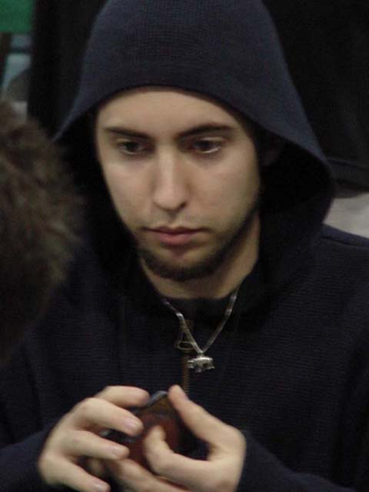
Mike Pustilnik continues to dominate this Pro Tour season. He broke further away from his closest rivals with a Top 8 finish at GP Valencia, following his win at PTLA. Spanish player Ricard Tuduri won the tournament that gathered over 400 players, many of whom were anxious to do well, since it would qualify them for a local Pro Tour (Barcelona).
Other notable personages in the Top 8 included finalist Olivier Ruel and the Top 4 duo of Noah Boeken and Ryan Fuller. All of these players have been riding the Grand Prix circuit hard this season, achieving excellent finishes along the way.
Full Coverage of GP Valencia

GRAND PRIX: KAOHSIUNG
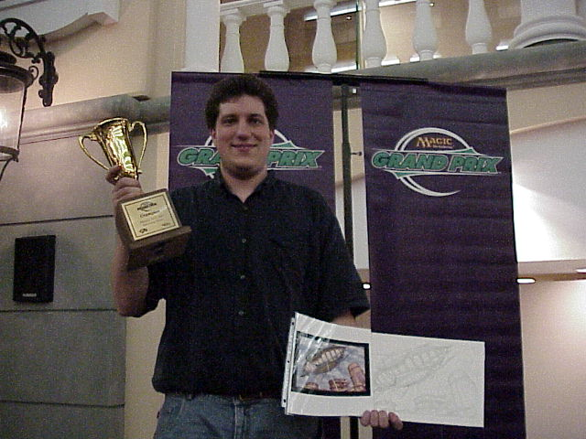
It was a very different story in this Taiwanese city. Barely over 200 players came to compete, with only a handul traveling from other Asian countries. After fourteen rounds, Tobey Tamber became the only player to make the Top 8 of all three Taiwanese Grand Prix held to date. This time around, this American player who moved to Taiwan to teach English, was able to go all the way, earning the champion title. Tamber recently made a Top 8 of Grand Prix: Kyoto, becoming one of a very small group of foreign players to make Top 8 at a Japanese Grand Prix.
Singapore's Nick Wong, who recently Top 8'ed on his home turf, finished in the Top 4, but the most notorious Top 8 finisher was Toshiki Tsukamoto. The two-time Japanese National Champion is now tied with another Japanese competitor - Satoshi Nakamura - for the third place in the number of Grand Prix Top 8 finishes, at six each. Tied for second are Jon Finkel and Randy Buehler, at 7 Top 8 finishes each. I hold the lead at 10 finishes, but not for very much longer, at this rate.
Full Coverage of GP Kaohsiung

5-COLOR PRO TOUR
Over the last year, "5-Color Magic," an unsanctioned Magic format, where a player is challenged to design a 250 card five color deck, and play for ante, has become increasingly popular. A "5-Color World Championships" were held earlier this year at Pro Tour: Chicago. Jason Moungey won the event. "5-Color" enthusiasts are now ready to organize a tournament structured similar to the Pro Tour.
Unlike the actual Pro Tour, the event scheduled to be held at the Origins convention in Columbus, OH this summer will only pay out $1,250 in prizes. Players can qualify by winning a special qualifier tournament near their home, or at Origins the day before the event. A total of 50 players will compete.
You can learn more about this format and the upcoming tournament at www.5-color.com.

YOUR MANA'S WORTH
In last week's Magic Trivia portion of the column, one of the puzzles I offered you asked for ways to make a player take mana burn twice during the same phase. The answer I had was as follows: "You need to have Oath of Lim Dul in play. When you are about to take mana burn for the first time, sacrifice a Su-Chi or Cathodian instead. You can then burn the mana generated by one of these creatures."
Several rules-savvy readers pointed out that this does not actually work. Level 4 judge and DCI NetRep Collin Jackson was kind enough to explain:
"If you take mana burn, the Oath of Lim-Dul triggered ability wouldn't go onto the stack until the next time a player receives priority, which is the beginning of the next phase. It's impossible to mana burn during the "beginning of your next step." You can only mana burn at the end of phases.
The Oath ability is triggered, so it can only resolve during a phase. If it was triggered by mana burn, that mana must have come at the end of the previous phase. The Cathodian mana will be given during the current phase, so any mana burn must occur during the current phase. Thus the two mana burn events will happen in different phases."
Apparently this would have worked under 5th Edition rules, as suggested by another reader. Live and learn.

MAGIC TRIVIA
Last week's question:
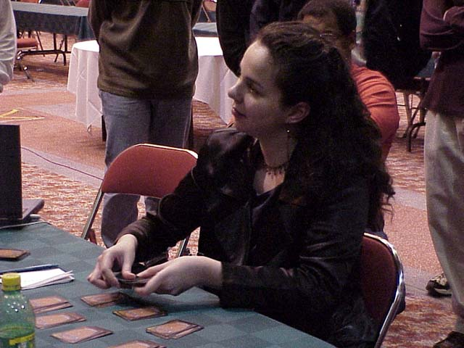
Ramen or no?
There are lots of interesting facts about Pro players, judges, tournament organizers and WOTC staff you probably do not know. Below is a list of amusing anecdotes, followed by a list of notable people in the Magic community. Everything listed below is true, and relates to one of the people listed below. Try to match the anecdote with the person. It may be pretty hard!
- Beat Tiger Woods in a round of golf
- Starred in TV commercials
- Wrestled in ramen noodles
- Family owns a jet
- Taught ballroom dancing
- Wrote for "Roseanne" TV show
- Air Hockey world champion
- Used to arm-wrestle professionally
- Published science-fiction author
- Lives in a palace
Answers:
- Brian Hacker (when he and Tiger both played golf in high school)
- Brian Selden (Brian acted in the old Magic commercial with an Orgg. He is one of the scientists)
- Michelle Bush (crazy college days)
- Bob Maher
- Darwin Kastle
- Mark Rosewater
- Tim Weissman (Tournament Organizer and president of Event Horizons)
- Sean "Hammer" Reignier
- Nicolas Labarre (Unfortunately, his work is available in French only)
- Ben Ronaldson (Lives and works at Hampton Court Palace in UK)
New question:
What card appears misprinted more than it appears in its corrected version?
Please do not e-mail me with your answers. There is no prize, this is strictly for fun. Correct answer will be posted in the next week's column.

BEST OF THE NET
Check out the tournament report from PTLA winner Mike Pustilnik, posted by Star City.

PLAY OF THE WEEK
Submitted by Victor Van Der Broek from The Netherlands:
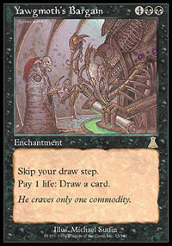
"During the second draft (complete Urza Block) at the European Championships of 1999 in Berlin, I was at the table where I had to win out in order to finish in the money. A draft that started out ok, with a Pestilence, Looming Shade, Congregate and various other decent W/B cards. In Legacy, B/W dried up incredibly fast, and halfway through the booster I realized my deck was too poor to ever go 3-0, and drafted cards I could use in Constructed decks. So on my draft pile about three Frantic Searches piled up, something which on it's own could be seen as a bad play of the week! Opening my Destiny booster I found a Yawgmoth's Bargain, and carefully placed that on my deck, which was looking jankier and jankier with every card I drafted. When I saw a Bubbling Muck somewhere 6th pick, I suddenly remembered I had a Pestilence and Looming Shade. Seeing how there were no creatures in there anyway, I might as well draft this and get a chance to abuse my couple of good cards. Another one of those made it onto my draft pile, along with a Scent of Jasmine. A devious plan had formed in my mind to make the incredible draft combo deck as well, so when I turned in my decklist, the Limited Bargain Monstrosity had become a fact.
In my first game of the last round I would play that Euro Championships, my opponent and I ended up in a creature stall; my deck was so kind as to give me 6 of my 10 maindeck creatures. At the end of his 8th turn, I played Congregate to go up to 40 life, and on my turn I dropped the Bargain, drew a bunch of cards, played the two Mucks, cast a bunch of Frantic Searches and played a Pestilence with enough life and mana to kill him and survive myself. My opponent, VERY surprised and rather baffled actually sided out his green fatties for red weenies.
Unfortunately my deck showed how bad it really was in the next two games, and I dropped from the tournament in order to salvage my rating a bit. It was fun though."

BAD PLAY OF THE WEEK
Sleep is not in any way overrated at Magic tournaments.
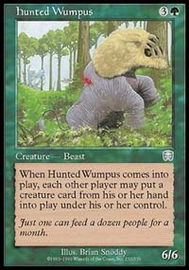
Humpus Wumpus?
During the round of Extended qualifiers a year ago, Gerard Fabiano played in his second PTQ Top 8 of the weekend, using a PT Junk deck. He drew a Demonic Consultation and cast it naming "Humpus Wumpus." The crowd was confused, and the judge asked him to name a real Magic card. After spending about three minutes, Gerard could still not remember the name of his largest creature - which, of course, happened to be Hunted Wumpus. In frustration, he finally named Cursed Scroll. Gerard's opponent had an Uktabi Orangutan and eventually won the game, which he probably would have lost if the mighty Humpus Wumpus ever hit play.
Thanks, Gerard, for sharing this story.
As always, please send good/bad plays, cool trivia questions, and other news to ashv@concentric.net.

